Example of ‘I’ and ‘C’ and ‘D’ indicators
Example for BRAMS Table to Insert (‘I’) a new Road:
Indicator | BRAMS_ID | OBJECT | NAME | START | END
I | 1234512345 | ROAD | ANN STREET | 0 | 300
I | 1234512345 | SUBURB_NAME | CBD | 0 | 200
I | 1234512345 | SUBURB_NAME | NEW FARM | 200 | 300
I | 1234512345 | ASSET_OWNER | BCC | 0 | 250
I | 1234512345 | ASSET_OWNER | MAINROADS | 250 | 300

Loaded in SAP:
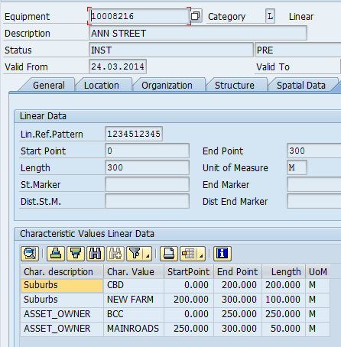

Example for BRAMS Table to Change (‘C’):
Indicator | BRAMS_ID | OBJECT | NAME | START | END
C | 1234512345 | ROAD | ANN STREET | 0 | 300
C | 1234512345 | SUBURB_NAME | CBD | 0 | 230
C | 1234512345 | SUBURB_NAME | NEW FARM | 230 | 250
C | 1234512345 | ASSET_OWNER | BCC | 0 | 250
C | 1234512345 | ASSET_OWNER | MAINROADS | 250 | 300
C | 1234512345 | SUBURB_NAME | ALBION | 250 | 300

Change in SAP:
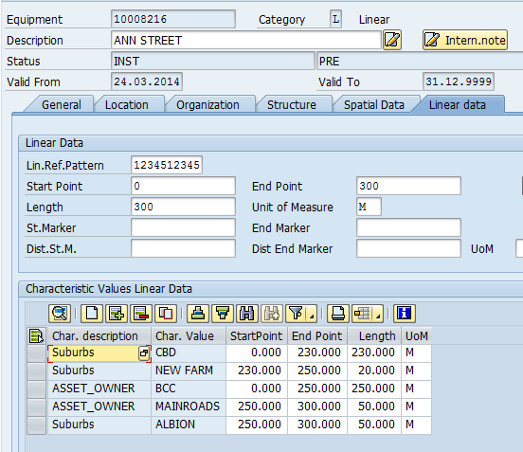

Example for BRAMS Table to Delete (‘D’):
Indicator | BRAMS_ID | OBJECT | NAME | START | END
D | 1234512345 | ROAD | ANN STREET

Delete in SAP:
